2020-1-SK01-KA226-SCH-094350

BODY FLUIDS

- they compose the internal environment of the body
- the main component is water, it can be: intracellular – contained inside the cells – 60%
extracellular - bodily fluids – 40%
The main extracellular fluids in a human body are: blood
lymph
interstitial fluid
Blood
- Comprises 8-9% of body weight - 5-6 l.
Functions:
- transport - oxygen from lungs to the tissues and organs, CO₂ from tissues to the lungs, nutrients from the digestive system to the tissues, collecting the metabolic waste and its transport to the kidneys, distribution of hormones, vitamins and other important substances
- thermoregulation – distribution of heat from the core to the body
- maintenance of a steady osmotic environment in the organism
- maintaining of the pH of the internal environment
- protection from pathogenic organisms and substances (immunity)

Composition of blood:
- blood plasma (50-55%)
inorganic substances (water, salts, etc.)
organic substances (proteins, glucose, fats, vitamins, hormones, etc.)
- blood cells (45-50%)
red blood cells (erythrocytes)
white blood cells (leukocytes)
granulocytes (neutrophils, basophils, eosinophils)
agranulocytes (lymphocytes, monocytes)
platelets (thrombocytes)

Blood plasma
- a liquid of light amber colour (the pigment bilirubin), comprised of inorganic and organic substances
- 90% of plasma is water with dissolved salts (maintains the pH of blood - 7,4).
- contains calcium necessary for blood clotting, muscle function and bone structure
- organic substances include proteins (albumins, globulins, fibrinogen, prothrombin), glucose, fats, vitamins, bile pigments, urea and uric acid.

Blood cells
Red blood cells
- biconcave discs of red colour (hemoglobin), in humans and other mammals without a cell nucleus
- their main function is the transportation of breathing gases
- they are produced in the bone marrow (influenced by the hormone erythropoietin)
- they are broken down in the spleen
- their lifespan in a human is 100-120 days

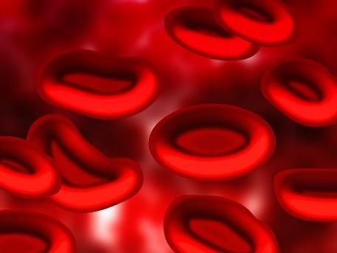

White blood cells
- cells of various shapes and functions
- produced in the bone marrow, spleen and lymph nodes
- their lifespan depends on the type - 10 days to 5 months
- their main function is to provide an immune system of the organism

Types of white blood cells:
1. granulocytes – cells which have stainable granules in the cytoplasm, they take a major part in the immune processes of the organism because they are capable of diapedesis (passage through vessel walls) and phagocytosis (ability to engulf and eliminate pathogens).
According to the type of staining of granules in the cytoplasm they are divided into:
- neutrophils – stainable by neutral dyes, they ingest bacteria
- eosinophils (acidophils) – stainable by acidic dyes, they suppress the effects of histamine
- basophils – stainable by base dyes, they produce heparin

2. agranulocytes – they lack stainable granules
Divided into two groups:
- lymphocytes – responsible for cell-mediated and humoral immune responses of the organism
- monocytes – engulf pathogens
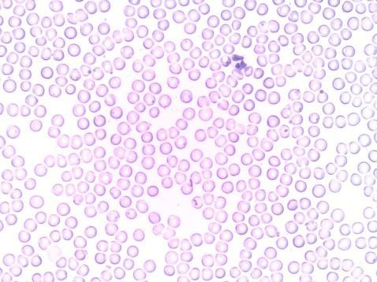
Platelets
- very fragile cell fragments of megakaryocytes
- lifespan of approx. 4 days
- the main function is blood clotting and stopping bleeding
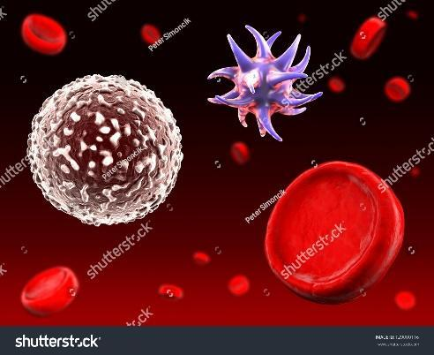

Stopping the bleeding - hemostasis
Process:
- vascular spasms (vasoconstriction) – constriction of a blood vessel at the damaged place
- platelet plug formation – adhering of the platelets to the wall of the injured vessel, forming a plug and its reinforcement by fibrin
- clot formation and plugging the injured vessel
The essence: transformation of a soluble plasma protein fibrinogen by the action of thrombin into a non-soluble fibrous fibrin at the presence of Ca2+ and vitamin K

Blood types
- the essence of the existence of of blood types is the presence of a foreign substance – agglutinogen (antigen) - on the membrane of red blood cells, against which antibodies – agglutinins- are formed in the plasma, while agglutinin must not be aimed against its own agglutinogen.
- the ABO system: there are four blood types recognised in humans: A, B, AB, 0
A agglutinogen A agglutinin anti-B
B agglutinogen B agglutinin anti-A
AB agglutinogens A and B none
0 no agglutinogen agglutinins anti-A and anti-B

