DIGI SCHOOL 2020-1-SK01-KA226-SCH-094350
Communication – subdivision, importance
Communication: 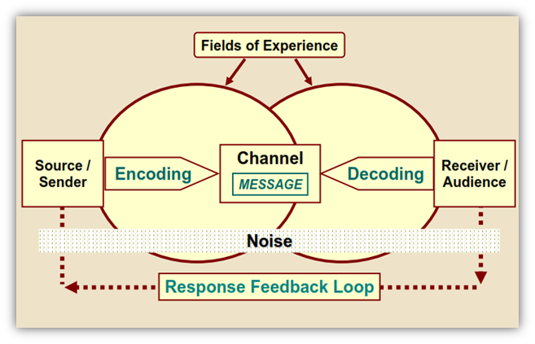

Main functions of communication
- Informative function - clearly, simply and understandably formulate the information
- Motivational function – through the communication stimulate to desired action and do effective work
- Contact function – communicational contact with a partner through the whole act of communication
- Emotional function – through communication create a space for nurturing the communicational needs of social contact (i.e., the possibility to express certain thoughts, opinions, feelings)
- Self-recognitional function – the ability of self-reflexion, because each communication participant through their own contribution to the dialogue reflect their own self-confidence, self-perception.

Ways of communication:
Direct – face to face conversation
Indirect – communication participants are divided by time and space, this also includes photographs, illustrations, pictographs
One-sided communication – speaker´s monologue
Both-sided communication – listener and the speaker interchange their roles
Group communication – more participants are present, all with different viewpoints
Positive communication – expresses agreement
Negative communication – expresses disagreement
Aggressive communication – offensive, harmful communication
Assertive communication – enforcing our rights but not at the expense of others
Manipulative communication – uses dishonest forms of doing things
Intrapersonal – inner monologue
Interpersonal – communication between two or more people
The most common subdivision of communication:
- Verbal communication – uses words
- Non-verbal communication – communication with other means than using words
- Communication through deeds
Verbal communication is also influenced by personal traits. Assertive communication has a socially desired character – self-promoting behaviour that also respects the rights of others.
Non-verbal communication:
Eye contact – type of look
Facial expression – movements of eyes, mouth, facial muscles
Kinesics – movements of body, walk
Gestures – hand movements
Haptic – touches
Proximity – distance from others
Territoriality - space and its occupation
Posture – body, hands, and legs positioning
Paralinguistics – tone of voice, speed and fluency of speech
Chronemics – dealing with the time while communicating
Neurovegetative reactions – human reactions on communication stimuli – shaking of hands, blushing
Environment – says about the person living within the given environment
Props – overall looks, adjustment of appearance, scent, car, house

Active listening:
- Non-verbally expressing acceptation, understanding
- Asking questions, reformulate thoughts
- To be empathetic
Importance of assertive listening:
- Helps to create an atmosphere of conversation
- Helps to create the relationship with a partner
- Obtaining information

Effective and optimal communication

- Leads to positive effect, result
Principles of effective and optimal communication
- Show interest, don't interrupt
- Speak about things that are interesting for others too
- Handle criticism and orders carefully
- Recognize your own mistakes
- Praise
- Be empathetic
- Smile often
- Don't belittle others
- Don't complain, don´t talk down to people
- Don´t be moody
- Don´t give unsolicited advice
- Avoid saying: always, never, still, etc.

