Elements of a computer network and connections

Elements of a computer network are all the devices connected to a computer network which send and receive data to and from the network.

Computer networks comprises of these **devices:**

* **modem -** modulator**-**demodulator, it provides the transfer of digital data via an analogue line. Digital data is modulated to be transported by an analogue line and a modem on the other end of the line demodulates the data back into the original form. 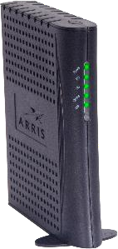
* **repeater** – a device amplifying the signal between two remote devices in a network

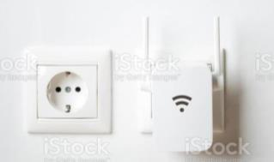

* **hub** –a central node of a network**.** Data received from any of the devices is amplified and sent to the other devices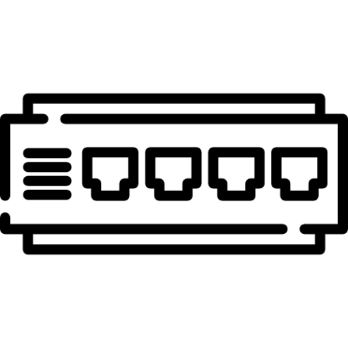
* **switch** – connects two or more devices in a network and only sends the data to the required ports

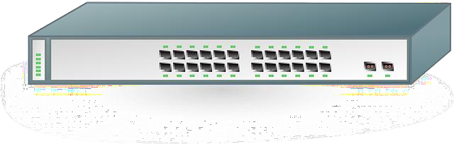

* **router** – a device collecting data from various sources in the local network and sending them to various destinations in the overlay network. It contains security mechanisms.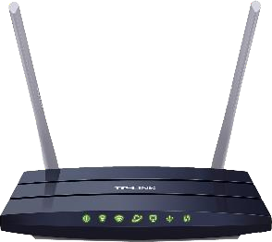
* **network interface card** – expansion card in a computer allowing the connection of the computer into a computer network

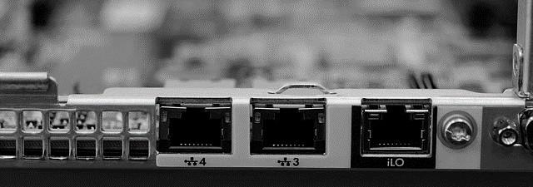

* **antenna** – a device used to transmit and receive a signal in communication via wireless technologies 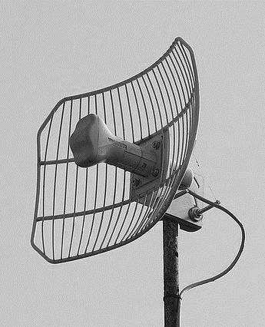

Internet connectivity options:

# cable connection

* + **Dial-up access** **–** via a phone line, a modem is used; it is very slow (max. 56 kbps), rather unreliable, the phone cannot be used while connected to the internet,
  + **ISDN** –phone line, two channels are used, each with the speed of 64 kbps; it is possible to make calls and be connected at the same time (the speed is 64 kbps) or use both channels for data transfer (the speed is 128 kbps),
  + **DSL** –a quick and reliable connection, the speed is in Mbps; households usually use ADSL **–** the speed is higher in the direction to the consumer, this connection is not available everywhere, the limit is the distance from the digital central
  + **VDSL** – fast and reliable
  + **optical cable** –high transfer speed

# wireless connection

* + **microwave connection** –line-of-sightconnection to the transmitter of the provider, although without the need to use cable lines, the speed is Mbps (up to 54 Mbps),
  + **mobile broadband** –once old and expensive, today many types of connection, with the speed of several Mbps (EDGE),
  + **satellite broadband** –expensive, usually used only where there are no other options

**Wireless connection in PAN networks** is done via:

* waves of infrared light (IrDA),
* Bluetooth,
* wi-fi.

Connection comparison:

* cable connection (metal or optical)
  + advantage – security and reliability,
  + disadvantage – lower accessibility (the need to lay cables, digging, drilling in building, higher expenses),
* wireless connection
  + advantage - accessibility,
  + disadvantage – lower security, being influenced by the weather and obstacles in the way of the signal (buildings, trees).

**Internet Service Provider (ISP)** –provides access to the internet services to the end user for a fee. It should guarantee a minimum transfer speed. The speed of downloading is usually higher than the speed of uploading.

**Literature**

Skalka, J. – Klimeš, C. – Lovászová, G. – Švec, P.: Informatika na maturity a prijímacie skúšky, Enigma Publishing, 2017, ISBN 978-80-89132-49-2

Šnajder, Ľ. – Guniš, J. – Gunišová, V. – Jašková, Ľ.: Informatika pre stredné školy Práca s internetom, SPN, 2008, ISBN 978-80-10-01518-4