DIGI SCHOOL 2020-1-SK01-KA226-SCH-094350
Etiquette, business etiquette – table manners

Etiquette

The word etiquette is of French origin. Etiquette means a shortcut, label and a ceremony, that is, it is the order of a certain ceremony.
Etiquette is a compilation of historically created and traditionally fixed rules of behaviour. Those are the rules of courtesy adopted in particular society.
Humans have always been social creatures and so they had to respect the social norms. Since the beginning people created rituals – at weddings, funerals, wars, business – and their non-compliance led to exclusion of the unadaptable individual from the tribe or society.
Etiquette evolves just as human society so it reflects the level of social development. We all consciously or subconsciously follow rules that were set by our parents or that we observed and accepted as our own.
Good manners create cultivated relationships between people. Politeness brings people closer together.
Etiquette can be significantly different depending on specific era and cultural background.
Business etiquette
In the world of business etiquette also work the rules that many of us learned in the social etiquette a little differently.
Work etiquette or business etiquette states the rules that should be followed during a successful business meeting. How to make a phone call, shake hands, how to introduce oneself, submit a business card, dine properly.
Table manners
Setting the table in an appropriate way belongs to some sort of etiquette soft skills, that are mastered by less and less people. However, if you plan to invite your family to a Sunday lunch or if you want to organize a smaller celebration with your friends, it is always a good idea to know at least the basics of formal table manners.
The basis for the right formal table manners is a clean and sufficiently large space. Make sure the main dining table is spacious with the right number of chairs.
The table should be covered with a tablecloth. Regardless of the colour and pattern, the table cloth should be ironed flat and should not reach over the table's edge further than 30 centimetres.
French seating plan:
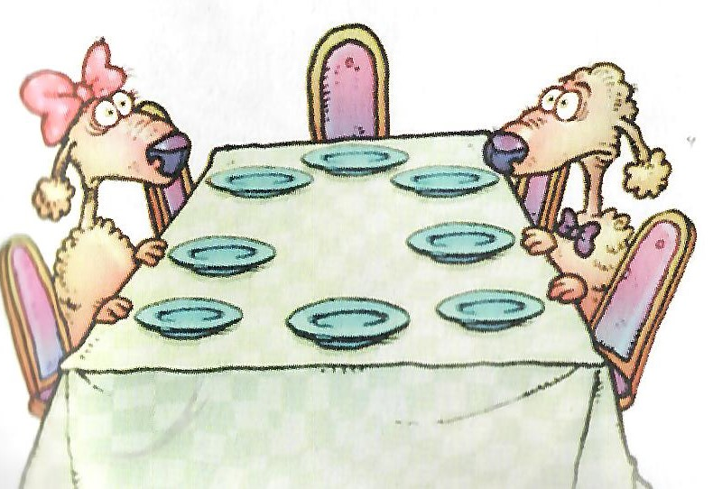
- The hosts are seated opposite each other,
- To the right-hand side of the male host the most important female guest is seated,
- To the right-hand side of the hostess the main male guest is seated,
- The more important the guest, the closer he is seated to the hosts.
English seating plan:
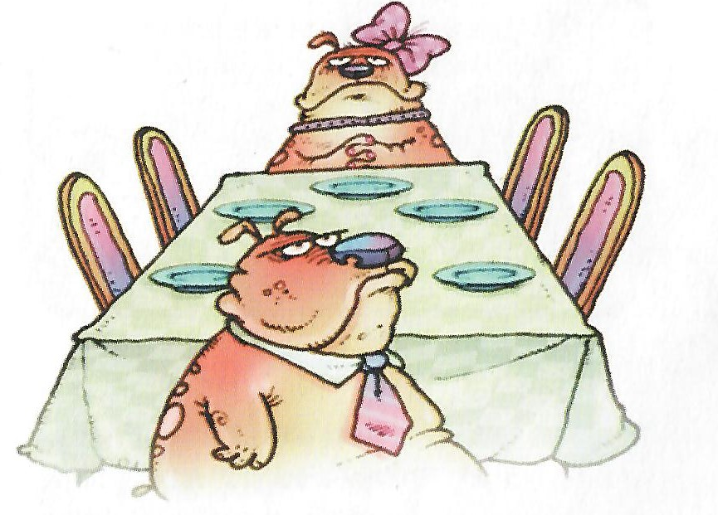
- The hosts are seated at the ends of a long table opposite each other,
- The other principles follow the French way of seating.
When dining at a round table we use one of the ways but we only imagine the table corners.
In business etiquette the host sits at the head of the table, opposing him or to the right-hand side of him sits the guest of honour – business partner of the highest ranking.
The others sit relaxed, if women are present, alternating seating should be tried.
While being seated, the first to sit down is the guest of honour, the host sits down as the last.
During a business lunch or dinner, it is inappropriate to stand up, one should prepare for that so they won't be necessary to leave the table. If it is inevitable, it is possible to leave the table between two courses.
If a woman stands up, all the men at the table don't have to stand up as it was customary in the past, only the host should do so, or just indicate that.
In case of any accidents during dining leave their removal to the waiter.
In business etiquette the rule applies that who invites is also the one who pays.
Payment is to be discussed in advance.
The order of dining courses:
- Aperitif – to encourage the taste – hard liquor, herbal liqueur
- Cold appetizer
- Soup or broth
- Warm appetizer
- Main course
- Dessert – cheese or a cake
- Coffee
- Digestive – for better digestion - Brandy, Fernet, fruit spirits
- For lunch it is enough to serve 3 to 5 courses, for dinner a larger number of meals is prepared.

Placement of the dishes on the table:
- Dishes should be put about 3 centimetres of the table edge
- Depending on the number of courses we begin with the plates
- On a large shallow plate for the main course, we put a deep plate for soup
- Left from the plates the forks are placed, the largest being closest to the plate
- We place a large knife to the right from the plates, sharp edge turned to the plate, an appetizer knife and a spoon bottom down. Right in this order.
- Above the main plate on the left, there should be a small plate for the pastries with appropriate cutlery and to its right there should be the glasses.
- Paper or fabric napkins can be placed directly on the plates or next to the forks.

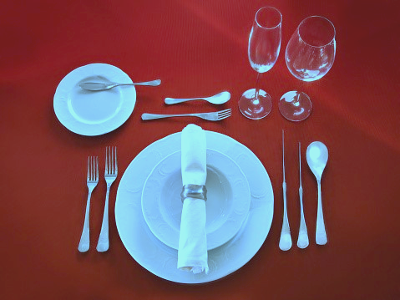

While dining:
- We don't swing on the chair, don´t go under the table, don't kick the neighbours,
- We don't make sounds with our mouths while eating, we don’t burp
- Our elbows are placed next to us, not on the table
- We start eating together, when the host says “enjoy your meal”
- In business etiquette we don't say anything before the meal, the host grabs the cutlery, can add a smile, nods his head.
Golden rules of table manners:
- Paper napkin serves for wiping our mouth
- Fabric napkin has to be placed on our lap, when no longer needed, we place it folded next to the plate
- Dishes are served from the left and are taken away from the left
- We can help ourselves to the meal more than once except for the soup
- The plate has to be tilted away from us, cream soup should not be eaten entirely
- We cross the fork and the knife if we want to continue eating
- In business etiquette the once used cutlery must not touch the table cloth, it has to be placed on the edge of the plate so it cannot fall off or slip into the meal.
- The knife and the fork are placed parallel if we are done eating
- We use our bare hands for eating only if we have the so-called finger bowl – container with lukewarm water
- We never lick the knife nor the spoon we used to stir our coffee
- In business etiquette we can only bite the bread during breakfast, at dinner time we break it off
- When drinking coffee or tea away from the dining table, it is necessary to lift the cup together with the saucer
- Tea bag has to be placed on a separate saucer never the one with the cup, in extreme case we can place it on the spoon and so to the edge of the saucer

