Format Cells

Cells contain all sorts of information according to need. To arrange the data well and make them easy to read, formatting is necessary. Cell format unifies the data and improves the appearance, too. Format cells are only a definition of how the content of the cell should look. It is found on the Number tab of the Home bookmark.

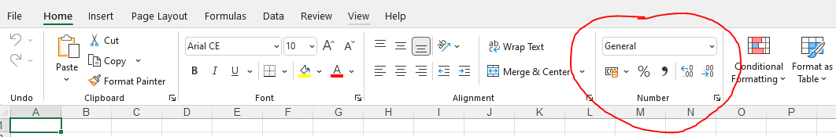

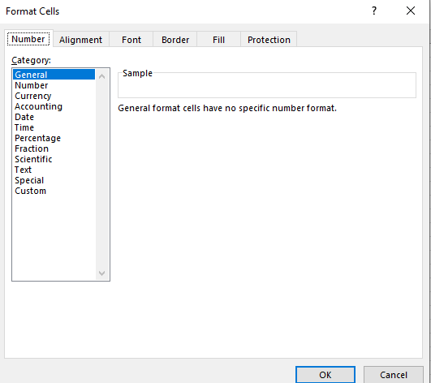

There three categories of the format of a cell:
- general
- specific
- custom

General format the default format for all the cells in the spreadsheet. According to what is written in the cell, it will
- remain default when a number is written
- adjust to the width of the column. If the number is too large for the cell, Excel will show the # symbol.
- keep the format unchanged even if the data is modified
- change to the date format when a date is inserted.

Specific format: all sorts of formats apart from General and Custom. It is various types of showing the data in the cell, e.g., the date in the USA or the UK, decimal numbers, etc.

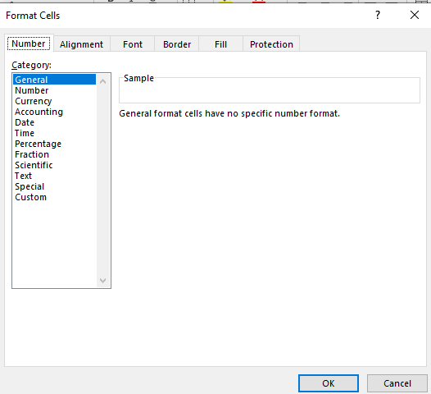

Custom format: adjusting the format according to specific needs, for example:

  - text before or after the number in the cell (type # ##0,00 and the required text in speech marks, e.g., # ##0,00″kg“)
  - a certain character in the cell (type @* and the required text)
  - alignment by the decimal point (type ?; typing 0,0?? shows a number with three decimal places)
  - date and time (d = day, m = month, y = year)

Literature
https://pohodovainformatika.sk/ms-excel/excel-navody-vysvetlenie/format-buniek-vlastne/
https://support.microsoft.com/sk-sk/office/vytvorenie-vlastn%C3%A9ho-form%C3%A1tu-%C4%8D%C3%ADsla-78f2a361-936b-4c03-8772-09fab54be7f4

