Formulas
Cell reference is the name of cell by row and the column where it lies. When doing calculations, relative cell references are used, not the numbers in them. It is done because when changing the values in the cells, the result is recalculated automatically so there is no need to do the calculations manually.
The expression of a calculation is called a formula. It begins with the symbol of = (equals).
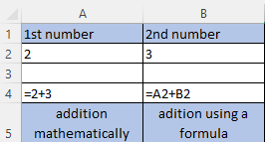
After changing the numbers:
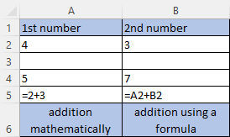

When calculating, the mathematical operations of addition (+), multiplication (*), distraction (-), division (/) and squaring (^) are used. The priority of the operations is the same as in mathematics – it is changed by using parentheses ().

Copying formulas
When copying (filling) the formula, the cell references of the copied formulas are changed automatically. The cell reference is a relative position in relation to the cell of the formula.
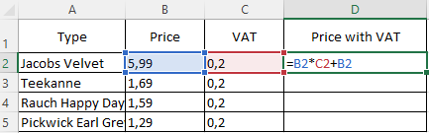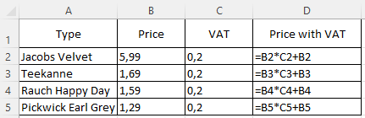

To avoid changes in the cell references, absolute cell references are used by putting the symbol $ in front of the column letter and the row number (the F4 key).
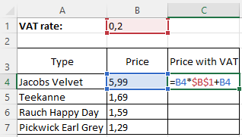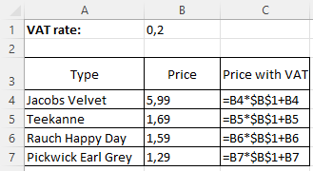

Referencing
- Relative (e.g., B2, changes when copying)
- Absolute (e.g., $B$2, does not change when copying)
- Mixed (e.g., B$2 or $B2, one of the references does not change)

Example:
- What will be the formula on the C3 cell after copying the formula from C1 to C2:C3?
- What will be the value in the D3 cell after copying the formula from D1 to D2:D3?
- What will be the formula in the F3 cell after copying the formula from E1 to E1:F3?
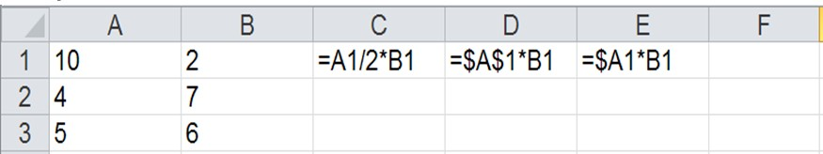

Solution:
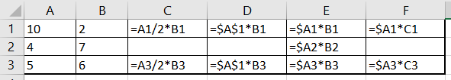

- c)
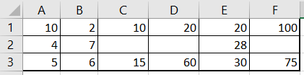

b)
Literature
Mgr. Štefan Máté, Informatika pre 7. ročník, 2011

