2020-1-SK01-KA226-SCH-094350

THE HUMAN HEART

- is a hollow muscular organ in the middle compartment of the chest cavity (mediastinum), enclosed in a protective sac called the pericardium
- made of a specific muscle type with three layers:
- the outer layer – epicardium
- the cardiac muscle – myocardium
- the inner layer - endocardium

The structure of the heart
- the interventricular septum divides the heart into the left and the right heart
- there atria in the upper part (atrium)
- the lower parts are called ventricles (ventriculum)

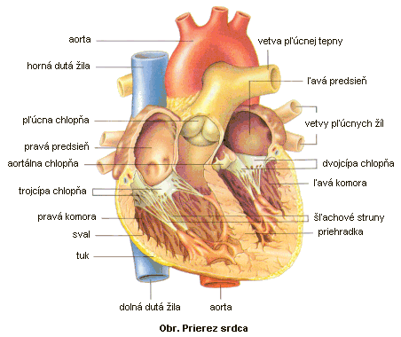
http://www.kickboxing.sk/kardio/Co%20by%20ste%20o%20srdci%20mali%20vediet.htm

Cardiac cycle
- the impulses for heart activity do not come from the brain but in the heart itself, from the electrical conduction system of the heart, which has four parts:
- the sinoatrial (SA) node – at the beginning of the right atrium
- the atrioventricular (AV) node – between the atria
- the bundle of His – in the septum, branches into the right and left branches
- the Purkinje fibers – go towards the apex of the heart and branch out
When the electrical conduction system malfunctions, it can lead to heart failure.
- by the cardiac cycle we mean the rotation between the systole (inflow of blood, relaxation) and diastole (blood ejection, contraction). The backflow is prevented by valves – between the right atrium and the right ventricle it is the tricuspid valve, between the left atrium and the left ventricle it is the mitral valve, where the aorta and the pulmonary artery enter, it is the semilunar valves (the aortic and pulmonary valves).
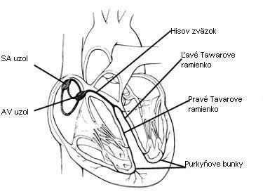
Obr. Prevodový systém srdca
https://www.upjs.sk/public/media/22891/Kardiovaskularny%20system.pdf

- the heart pumps approx. 5 l of blood per minute – cardiac output (rises with increased activity)
- when the blood is ejected, pressure is formed against the walls of the blood vessels and it is called blood pressure (values for a healthy individual: systolic - 100-120 mmHg, diastolic - 60-80 mmHg)
- blood ejected into the aorta widens the vessel and this pressure wave spreads into its branches and is called the pulse (most easily palpated at the radial artery). The normal pulse rate of a healthy individual is 70 beats/min.

