The History of Computers
Humans have always needed to obtain and store information to survive. They have used – apart from their fingers – various tools to compute. The oldest of the mechanical tools is called the abacus and its age is estimated to be around 5000 years.
It was a wooden or clay tablet with grooves, in which small stones were moved. These are called calculus in Latin, that is where the calculator got its name. The abacus was used in Ancient Greece and Rome and is still used in Japan and China.
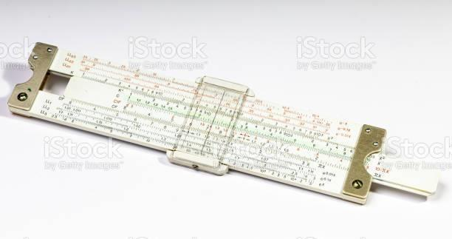
Another invention to make computing easier was the slide ruler. The principle is in replacing addition with multiplication, using logarithms.

The first mechanical calculators
The father of the era of the counting machine was Wilhelm Schickard, who built the first calculating clock in 1623. It used gears originally intended for clocks. The machine was used for addition and subtraction of six-digit numbers and was supposedly used by Johannes Kepler in his astronomical calculations.
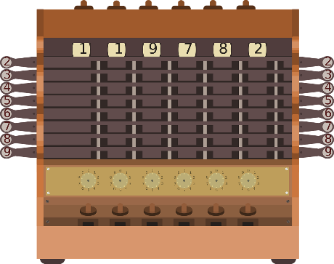

Another mechanical calculator was the so-called Pascaline, bearing the name after its inventor, the French philosopher, mathematician, and physicist Blaise Pascal. It served as a means of mechanical addition and subtraction of numbers and was proven to be a relatively remarkable and precise device with limited options.
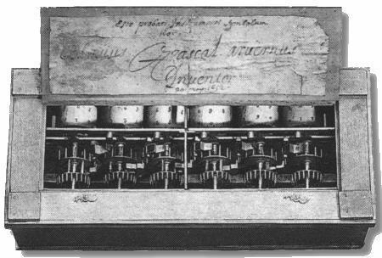
Source: https://docplayer.cz/105257466-Katolicka-univerzita-v-ruzomberku-historicky-vyvoj-pocitacich-strojov.html
More advancement was contributed by Gottfried Wilhelm Leibniz. His calculator could do addition, subtraction, multiplication and division and roots as well.,
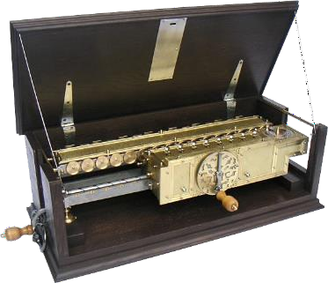
Source: https://hrsale.2021shopsfashion.com/content?c=leibnitzov%20kalkulator&id=15

Predecessors of computers
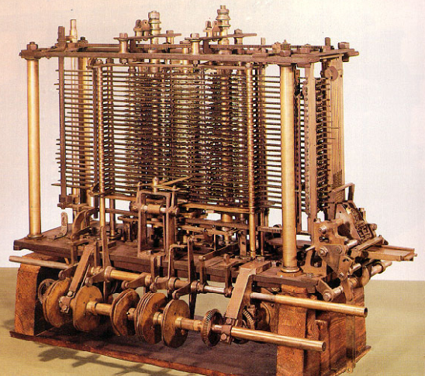
In 1834, the English mathematician Charles Babbage (1792-1871) created the first Analytical Engine where the calculations were to be done by a program. The sequence of mathematical operations was determined by programs on punch cards. It was inspired by the loom. However, the contemporary precision mechanics was not developed enough and the engine was forgotten.

Source: https://encyklopediapoznania.sk/clanok/7034/historia-pocitacov-a-pocitacich-strojov-v-rokoch-1-do-zaciatku-20-storocia
Augusta Ada King, the daughter of lord Byron, translated the description and the workings of Babbage’s engine from French to English in.1842. She corrected some mistakes and added her own thoughts. She is considered to be the author of the first programs.
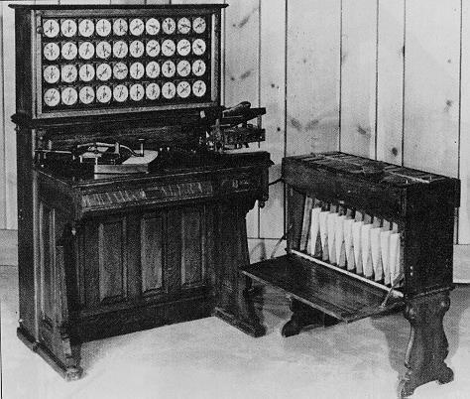
Designed by Herman Hollerith, an employee of the United States Census Bureau, an electromechanical tabulating machine was built in 1844, which was used in the next census in the USA.

Source: http://www.columbia.edu/cu/computinghistory/1890tabulator.html

The first computers
The first programmable computer was built by Konrad Zuse in 1936. This computer was called Z1.
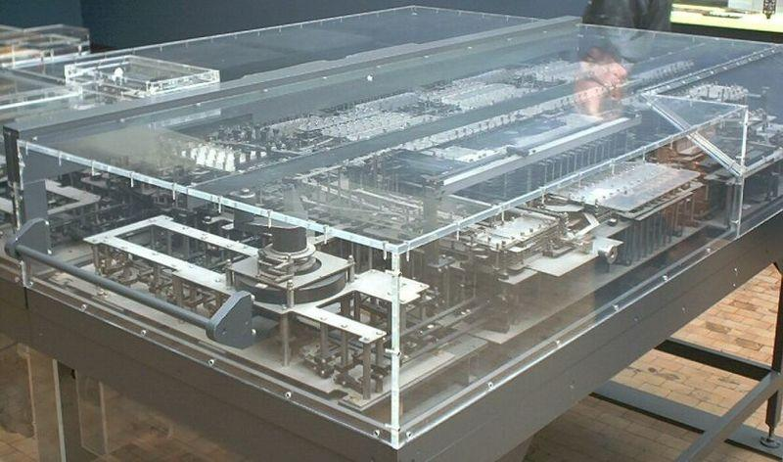

Source: http://www.columbia.edu/cu/computinghistory/1890tabulator.html
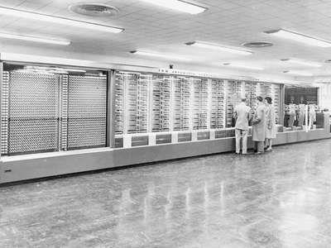
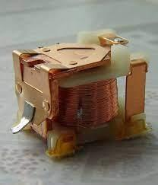
The main building block of the next computer was a set of relays (made of inductors and switches). It was called Mark I and weighed 5 tonnes and the American navy used it to calculate ballistic trajectories.

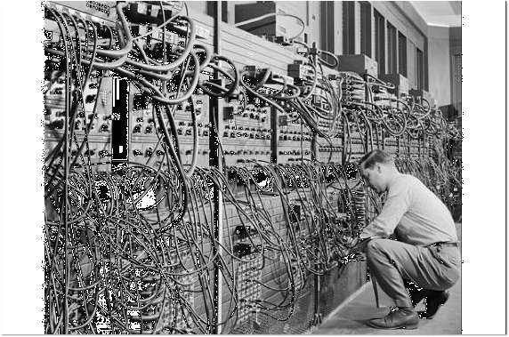
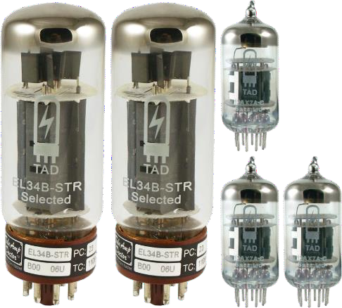
The first electronic computer was called ENIAC and was built in 1946. It took up a whole large room. It was used for calculations related to the first atomic bomb.
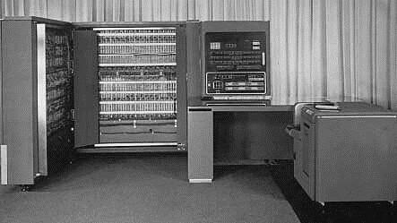
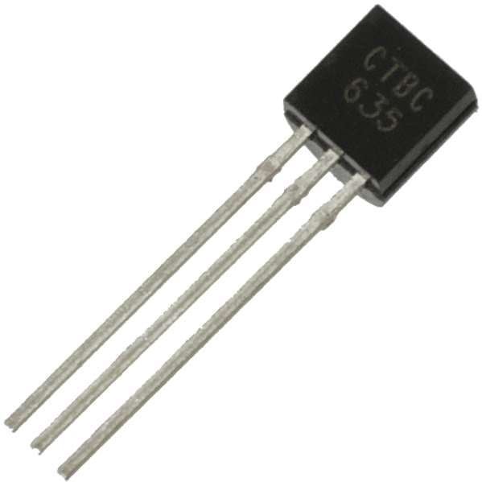
IBM 701 was the first digital electronic computer built with semiconductor parts – transistors.
Source: https://www.ibm.com/ibm/history/exhibits/701/701_141502.html
As computers develop, they get smaller thanks to integrated circuits, a set of electronic circuits of millions of transistors

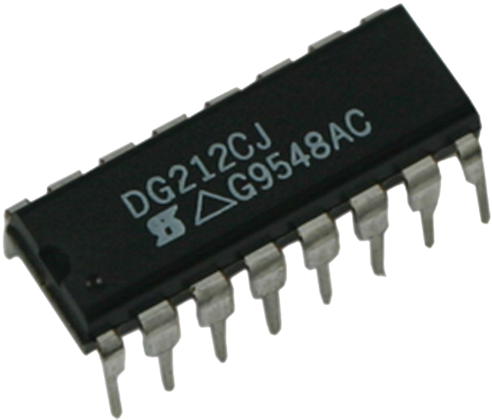

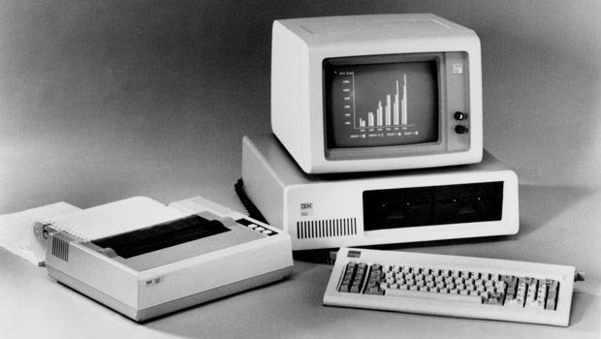
The first personal computer, starting the boom of home computers, was a PC by IBM introduced in 1981.
Source: https://tech.sme.sk/c/2843860/prvy-pocitac-predstavila-spolocnost-ibm-pred-25-rokmi.html

Literature
Kalaš, I. – Winczer, M,: Tvorivá informatika Informatika okolo nás,Slovenské pedagogické nakladateľstvo, 2007, ISBN 978-80-10-00887-2
https://sites.google.com/site/rosicova/studijne-materialy/hardware/historia-pocitacov-1
https://favpng.com/
https://www.shutterstock.com/cs/images

