Licencing and copyright

Creating software demands time, intellectual and financial means. Therefore, it is the intellectual property of the author/company and they own the copyright. Software is not bought as a whole – with the copyright – by purchasing it only a license is bought. It is an authorisation to use it under precisely stated conditions. Copyright is protected by copyright law. Software is created by large international corporations ((Microsoft, Apple, Adobe, etc.), but also by smaller companies in many fields (accountancy, filing, etc.).
When buying software, a license stating the terms of use is obtained. If the terms are kept, it is called legitimate software. It usually notifies the user that the software can only be installed after agreeing with all the terms of use. They determine how many devices the program can be installed on, whether or how the program can be distributed, what must not be done with the program (e.g., copy) and what the responsibilities of the author are or are not (usually stating the author is not responsible for the damage caused by using the software).
When buying software, there is often an appeal to register. This has advantages for both parties. The user is notified about the changes in the software in time, at times is allowed free updates and support and the author has information about the user to consider in further development.

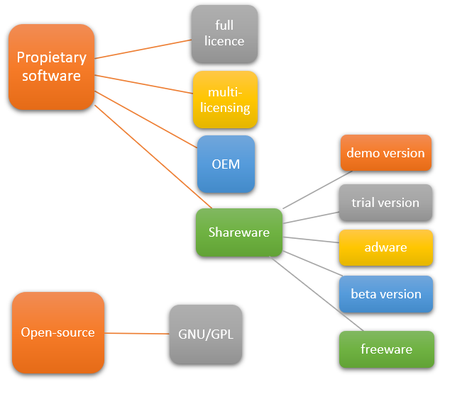

Software by license
- Proprietary software – limited use and copying
  - full licence – the right to use the full version
  - multi-licensing – allows the use of the program on multiple PCs. It is limited to a certain number of devices (e.g., 20) or a place (school). It is more affordable.
  - OEM – tied to the device with which it was sold (operating system, antivirus program, office program bought with the computer for a more affordable price)
  - shareware – allows the program to be tried and used for a limited time free of charge. After that time the user must pay or uninstall the program.
    - demo version – a version of the software with certain functions blocked
    - trial version – allows the full use of the program for a limited time for limited number of uses
    - beta version – a test version of a commercial program distributed free of charge in order to test or advertise it
    - adware – a program supported by advertisements, they can sometimes be removed for a fee
    - freeware – a program which can be used free of charge permanently if the terms of use are kept
- Open-source – software where the source code is accessible for studying the program, modifying or improving the source code and further distribution
- Commercial software – distributed for a fee
- GNU/GPL license – a license for free software that allows running the freely for whatever purpose, modifying and improving it and further distribution
- Public domain – intellectual property without exclusive intellectual property rights. The author either dedicates the work for public domain or the copyright has expired 70 years after the author’s passing.

Literature
Skalka, J. – Klimeš, C. – Lovászová, G. – Švec, P.:Informatika na maturity a prijímacie skúšky, Enigma Publishing, 2017, ISBN 978-80-89132-49-2
https://sk.wikipedia.org/wiki/Softv%C3%A9rov%C3%A1_licencia
https://licencieaautorskeprava.estranky.sk/clanky/typy-licencii.html

