Micro:bit Display

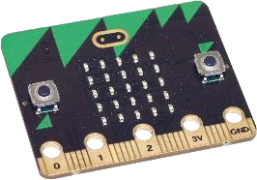
Micro:bit is a programmable minicomputer used as a great prop to learn writing software. The user can see or ‘feel’ the program.
It has inbuilt sensors which make programming more interesting and can be done in different environments. We are going to explore the block environment MakeCode, particularly into the library of commands to write text or displaying pictures.
The programs are to be tried at makecode.microbit.org.

The MakeCode environment
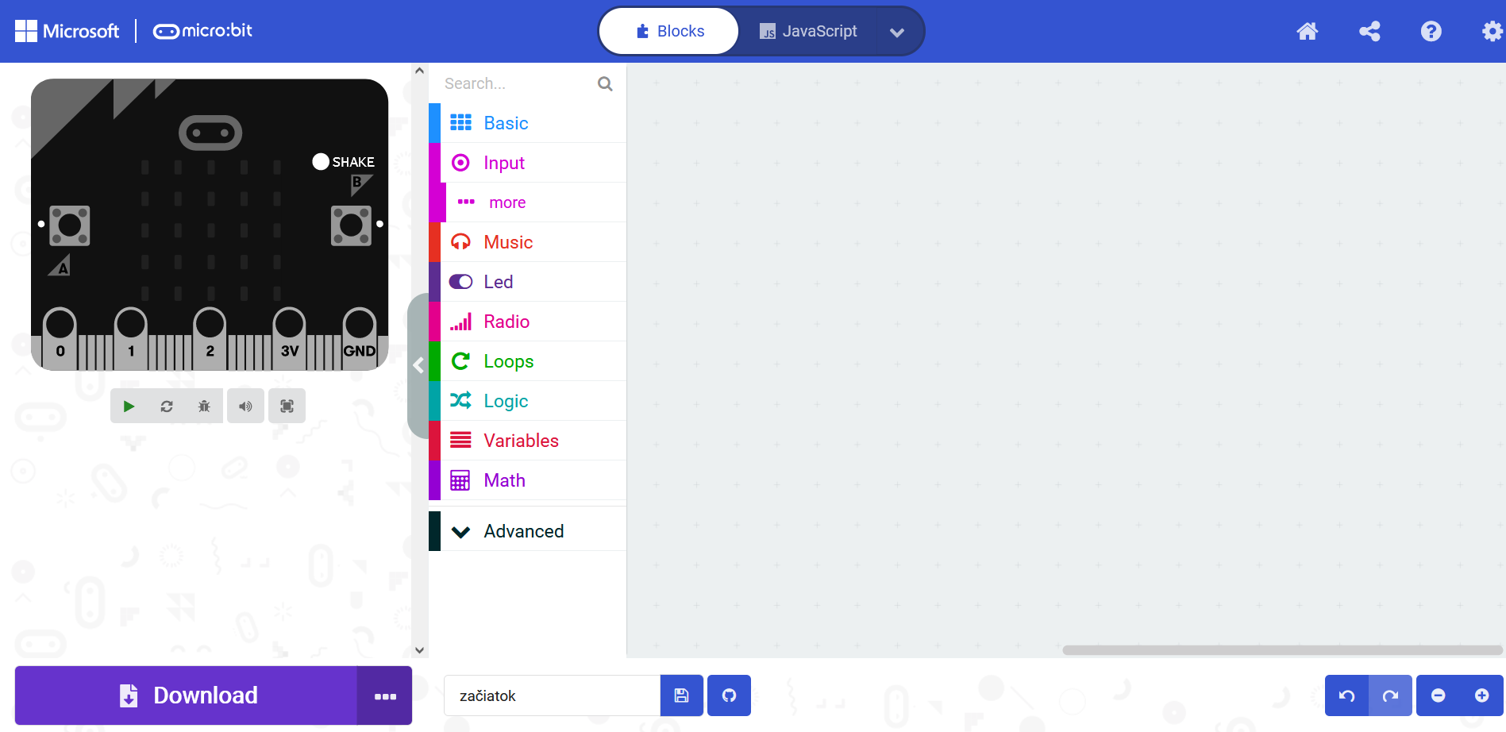
space for programming

command library

simulator

downloading the program

Selected parts of the Basic library:

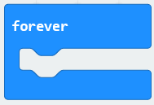 The program will be repeated.

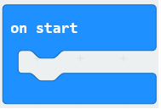 The program will start and finish when done.

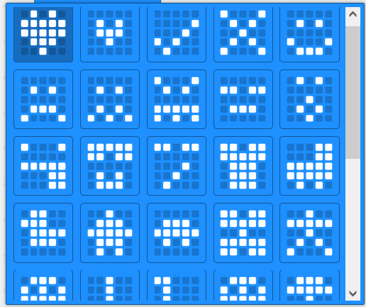
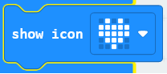 Shows a heart icon. If we want a different icon, the options will appear after opening the menu:

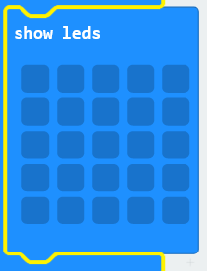 If we want an icon MakeCode does not offer, we can create our own.

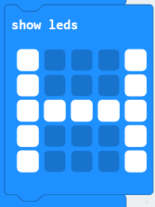 A left click on the grid activates the squares we want to display, in this case the letter H.

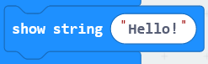Using this command will cause the text to scroll (letter by letter).

This command is used to clear the screen after finishing a task or at the end of a program.

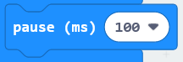 A command to pause in milliseconds.

Selected parts of the Input library:

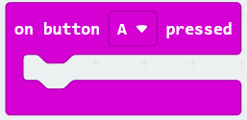 After pressing the A button, the micro:bit executes the command. After rolling out the menu we can choose the B button or press both buttons at the same time.

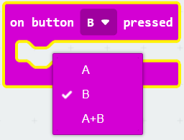

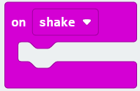 Micro:bit also has a movement sensor; therefore, it reacts to various events. This block will execute a command after shaking. There are other options for events, which can be accessed by opening the menu.

Writing a program
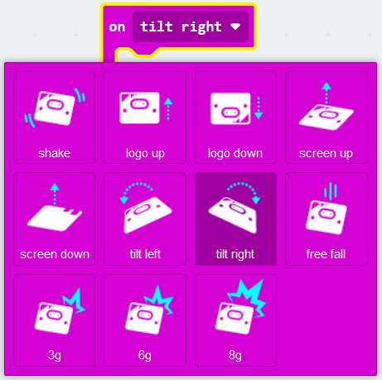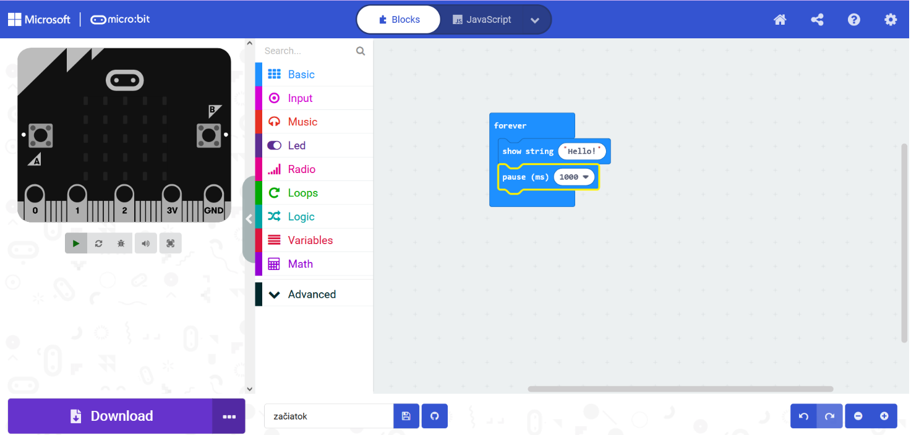
In MakeCode we click on a new project. Then we select the suitable commands from the library. In the space for writing the program we arrange the commands to form a unit. In the simulator the micro:bit program can be tested. When everything works, the program can be downloaded into the micro:bit.

Literature
https://www.ucimeshardverom.sk/materialy/microbit_makecode/
https://makecode.microbit.org/#editor

