Perun
The most important god that ruled over other godly beings. He drove a carriage pulled by a bull or a buck or he flew in the sky on millstones and created bolts of lightning. His weapon was an axe. He was the protector of agriculture; he spread the sun rays and dispersed the clouds.
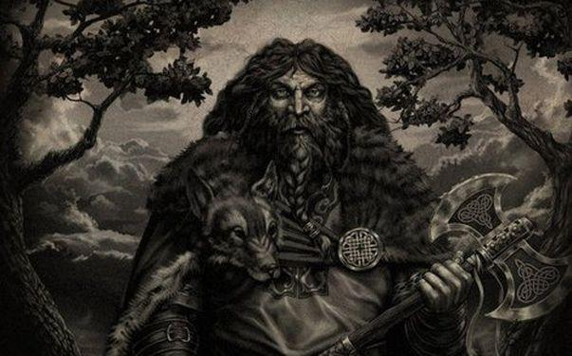

Veles

The patron of cattle, herds and wealth. He belonged to the oldest and the main gods, frequently depicted as the counterpart to Perun. According to legends he was also the ruler of the dead and the underworld.

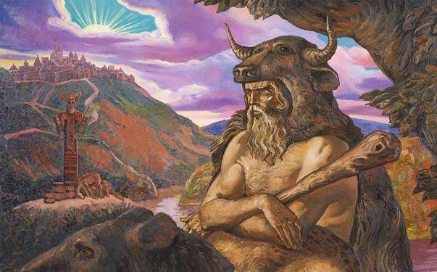

Mokosh

She represented the personification of the Earth – provider, the goddess of sheep, fertility and richness. The rocks were said to be her bones, the grass her hair, and the rivers were her veins. She was also recognized as the patron of femininity, home and order.

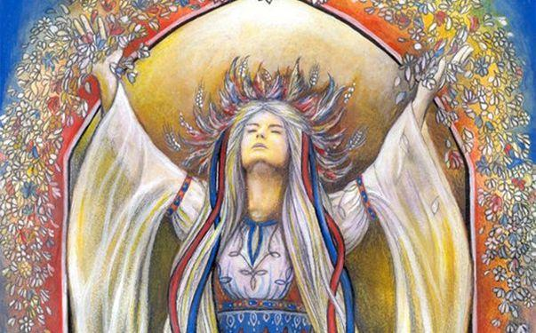

Morena

The goddess of winter and death, who is to this day connected with many traditions; as carrying out of Morena (a large hay puppet) and her throwing into the river in spring symbolizing the end of winter. She was considered to be the mother of demons.
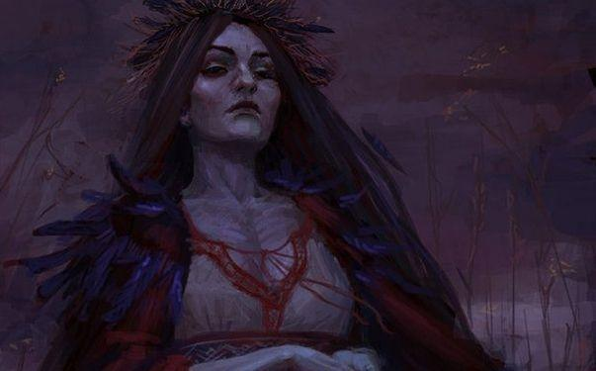

Vesna

Slavic goddess of spring and life. There is just a little information about her and it is not clear whether the information is genuine, so the historians are still uncertain whether she was an original figure bearing the name Vesna.

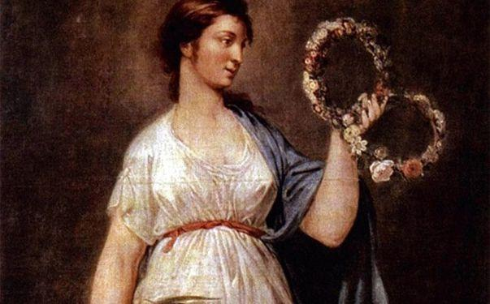

Svarog

One of the oldest gods, patron of the sun, fire and warmth, who stole the celestial disc – the Sun. Considered as the strict enactor who cancelled polygamy.

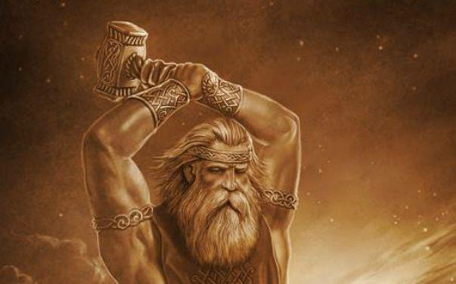

Svarozhits

The son of the god Svarog. Originally viewed as sun deity, later he gained the character of a warrior and protector.

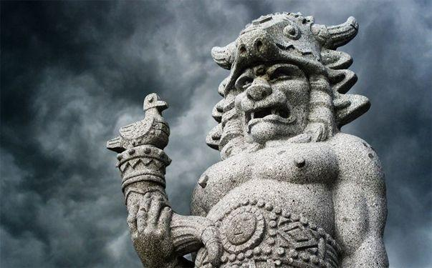

Zhiva

The daughter of Mokosh and wife to Svarozhits. She gave strength to plants and animals, she awakened to life, that is why she is considered the goddess of healing, she had the power to cure or even resurrect the dead. She was also the goddess of summer, crops, fertility and richness.

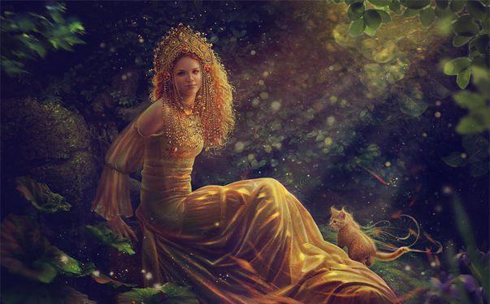

Belbog

The most important and at the same time the oldest sun deity of the Slavs. His name represented the power of the day and light. He was connected to clarity and white colour.

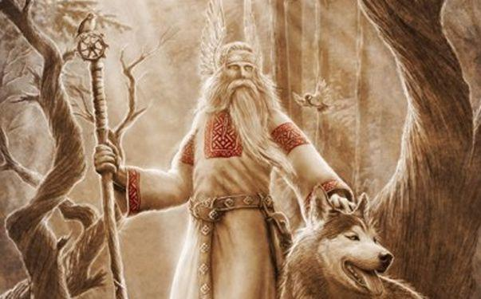

Chernobog

The god of night, black colour and evil. The days of winter solstice were dedicated to him. Because he was competing with his brother Belobog, the belief in the existence of Chernobog was influenced by Christianity – the contrast between the Devil and God.

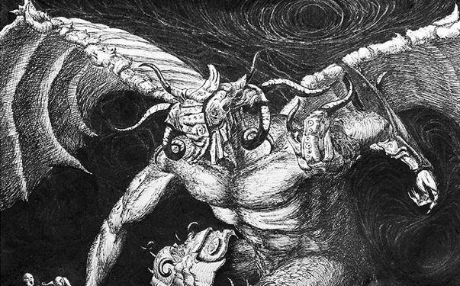

Source of visual material:

https://refresher.sk/27721-Aj-slovanska-mytologia-moze-zaujat-Spoznaj-bohov-a-myticke-bytosti-nasich-predkov

