Sorting and Filtering

To make the overview of spreadsheets clearer tools for sorting and filtering are used. They are located on the Home tab on the ribbon bar. It is important to have a well organised table with a heading. The heading is necessary for choosing the criteria of sorting and filtering.

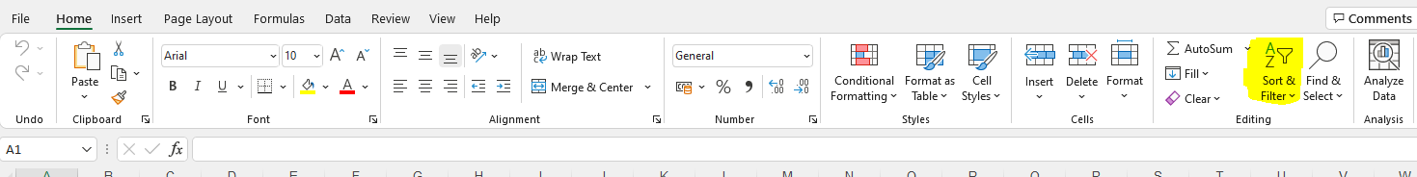

Sorting:

When sorting the values on a spreadsheet are shown according to the selected criteria.

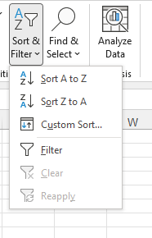
Sorting can be done:

- A to Z (ascending)
- Z to A (descending)
- custom

Custom sorting:
The user chooses the criteria by which the data will be sorted.

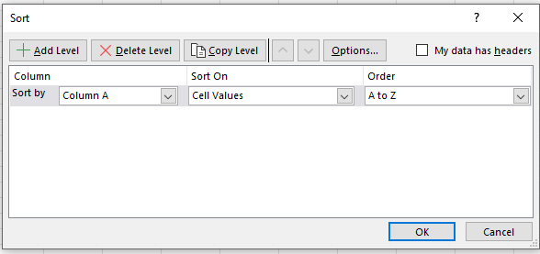

Filtering:

In this process the data not falling under the selected criteria will be hidden. The filter is activated by selecting a range in the heading and choose Filter on the ribbon bar.
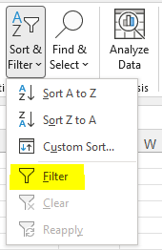

After that the criteria are selected:

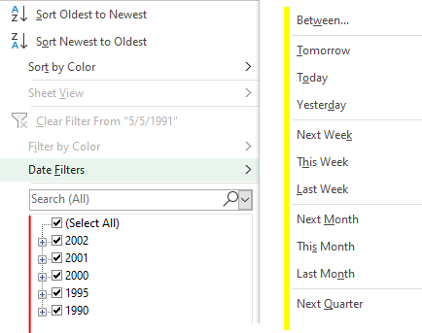

values by which to filter various criteria

Literature https://support.microsoft.com/sk-sk/office/filtrovanie-%C3%BAdajov-v-rozsahu-alebo-tabu%C4%BEke-01832226-31b5-4568-8806-38c37dcc180e

