2020-1-SK01-KA226-SCH-094350
THE LEAF (phylom)

- the lateral organ of the shoot
- has a regular position and limited growth
- a seasonal organ (except for evergreens)

- original functions:

  - assimilation – photosynthesis in leaves
  - breathing – gas exchange
  - transpiration – water evaporation
During their development, flowering plants can form various types of leaves:

- cotyledon – develops as a part of the seedling, provide nutrients to the plant during germination
- bract – modified leaf, a base of a which a peduncle grows
- lamina – primary place of photosynthesis
- petal – modified leaves forming a flower

External structure of the leaf

The leaf consists of the petiole and the lamina.

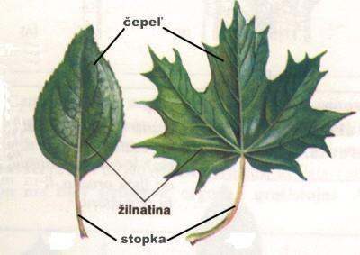
https://www.ta3k.sk/biokutik/index.php/rastlinypp/93-rastlinneorgany/96-list

Shape of the lamina (simple leaf):
- acicular, orbicular, elliptic, ovate, spear-shaped, linear, spatulate, etc.

Margins of the lamina:
- entire, serrated, dentate, crenate, sinuate, etc.
Venation:
- parallel, arcuate, palmate, pinnate, etc.

Arrangement on the stem:
- alternate, opposite, basal, whorled, etc.

Divisions of the blade: a) simple – undivided – the lamina is whole
- lobed – the blade is divided but the lobes do not reach the main vein
b) compound – the lamina is divided into leaflets. They can be palmately compound or pinnately compound. By the number of leaflets, they can be odd pinnate or even pinnate.

Internal structure of the leaf

bi-facial leaf
- the leaf of dicotyledons with a distinctive upper- and underside
- epidermis – one layer with a cuticle
- mesophyll – contains vascular bundles and two kinds of parenchyma:
      - palisade mesophyll – elongated cells packed with chloroplasts – photosynthesis
      - spongy mesophyll – cell of various shapes with a smaller number of chloroplasts – respiration

      - vascular bundles - collateral or concentric – they transport nutrients
- bottom epidermis – has stomata in it – transpiration and water management of the plant
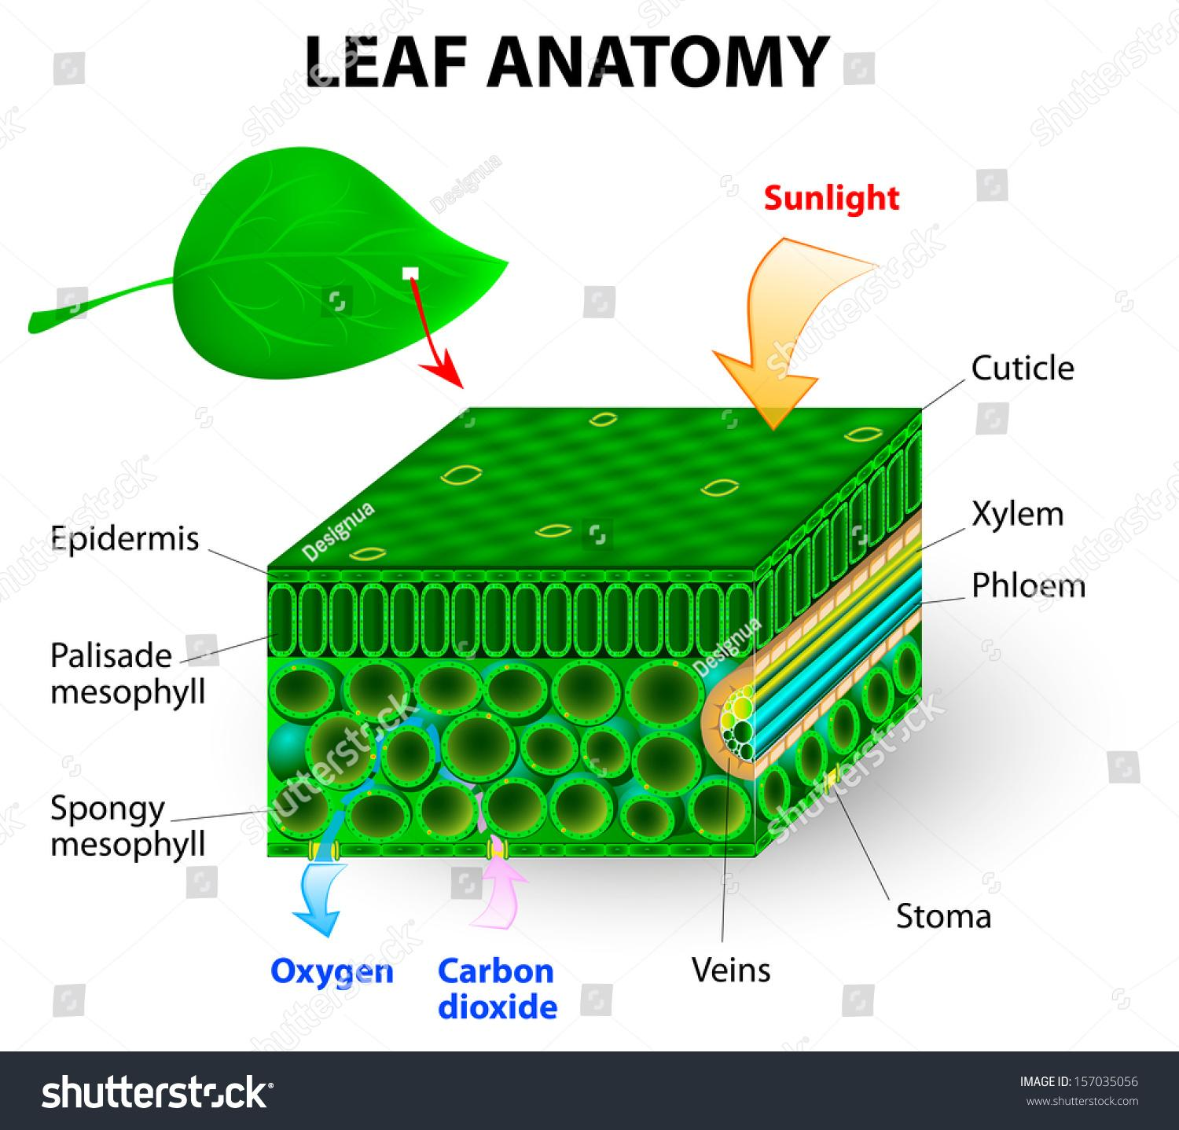

mono-facial leaf
- the leaf of monocotyledons
- the epidermis and the mesophyll are not distinguished – they both contain stomata

Modifications of the leaf
- leaves of carnivorous plants – glands in the leaves release a sticky secretion with
enzymes (common sundew)
- spines – a whole leaf modified (barberry)
- tendrils – coiling to another plant (pumpkin)

