THE URINARY SYSTEM

- is responsible for the removal of the waste from metabolism and toxins

The urinary system consists of:
- the kidneys (renes)
- ureters (ureter)
- the urinary bladder (vesica urenaria)
- the urethra (urethra)
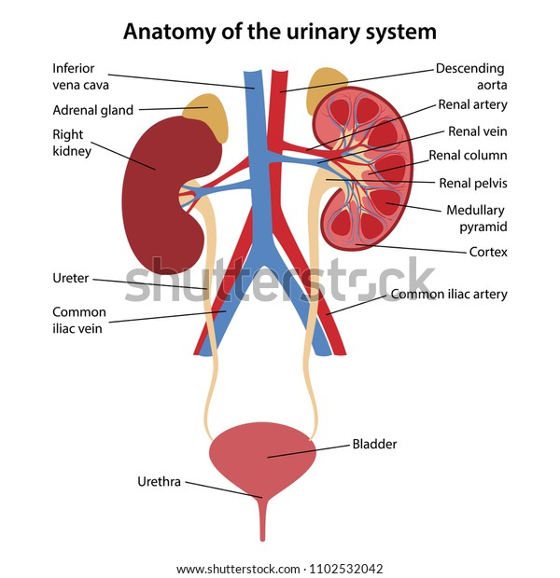
https://image.shutterstock.com/image-vector/anatomy-human-urinary-system-main-600w-1102532042.jpg

Structure of the urinary system
1. kidneys
- the main organ of the system, located by the spine in its lumbar area
- paired bean-shaped organs, approx. 12x6x3 cm large
- protected by a layer of fat
- consist of renal cortex with nephrons and renal medulla
nephron structure: renal corpuscle (glomerulus and Bowman’s capsule)
system of tubules (proximal convoluted tubule, loop of Henle, distal convoluted tubule)
renal medulla: consists of renal pyramids, whose apexes are surrounded by renal calyces collecting urine, which is then conveyed to the ureters and finally to the bladder
2. ureters - paired organs, approx. 30 cm long, leading to the bladder. Urine is conveyed by peristalsis (1 – 5 movements/min)
3. urinary bladder – a hollow muscular organ which stores urine and can hold about 500 ml
4. urethra – leads the urine from the bladder when pressure is increased in urination/micturition. It is shorter in females and has an independent opening, while in males it is longer and shares the opening with the reproductive system

The Process of Urine Formation
1. glomerular filtration – ultrafiltration of blood plasma, results in primary urine (150-170 l/24 hrs), whose composition is like blood plasma but without proteins

2. tubular reabsorption – reabsorption of water and some other substances, resulting in producing urine (1,5-1,7 l/24 hrs)

3. tubular secretion – removal of metabolic waste and excess substances

Urologic Diseases
Uremia - kidney failure and disruption of the internal environment.
Dialysis – in a dialysis machine - wasted is filtered from the blood, which then returns to the body
‘Floating kidney’ – a kidney changes position which can lead to renal tract obstruction

