**HUMAN CIRCULATORY SYSTEM**

*Function* – to transport blood to all the parts of the body and thus allow it to fulfill its main functions

*Parts of the circulatory system:*

1. **Heart** – central organ of the circulatory system
2. **Blood vessels** (arteries, veins, capillaries) – a peripheral system of tubes
3. **Blood** – body fluid

***Blood vessels***

* A closed system of tubes to transport blood in the body
* They have 3 layers:

1. **The tunica intima** – the inner layer
2. **The tunica media with muscles** - kruhovito a špirálovito usporiadaná svalovina
3. **The tunica adventitia of connective tissue** – contains nerves going to the smooth muscles

Types of blood vessels by function:

1. ***arteries*** – they carry oxygenated blood from the heart into the whole body. The exception is the **pulmonary artery**, which takes the deoxygenated blood from the right ventricle to the lungs to be oxygenated. The largest artery is the **aorta**, leading from the left ventricle and carrying oxygenated blood to all the tissues and organs.
2. ***veins*** – they carry deoxygenated blood from the body to the heart through the **superior and inferior venae cavae**. The exception are the **pulmonary veins**, which carry oxygenated blood into the left atrium of the heart. Another part of the venous system is the massive vein called **hepatic portal vein** leading into the liver.
3. ***capillaries*** – are thin, delicate veins without the two outer layers, which allows them to facilitate gas exchange with the bloodstream.

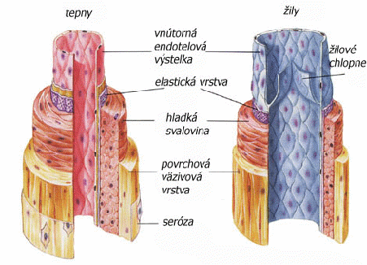

**Obr. Prierez stenou ciev**

**https://oskole.detiamy.sk/clanok/prudenie-krvi-cievami**

***Cardiovascular system***

It is divided into:

* **pulmonary circulation**
* the systole expels the blood from the **right ventricle** through the pulmonary valve into the **pulmonary artery**, which carries it into the lungs to be oxygenated and then returns into the **left atrium** by four **pulmonary veins**.
* **systemic circulation**
* the systole expels the blood from the **left ventricle** through the aortic valve by the **aorta** into the body, it delivers oxygen and binds carbon dioxide and returns into the **right atrium** by the **superior and inferior venae cavae.**

Another type of circulatory system is the **coronary circulation,** which supplies nutrition to the heart muscle. The coronary arteries branch from the aorta and lead straight to the heart muscle. When one or more of these arteries are blocked, **heart attack (myocardial infarctions)** occurs, which is damage to the heart muscle from starving for oxygen where the artery is blocked.

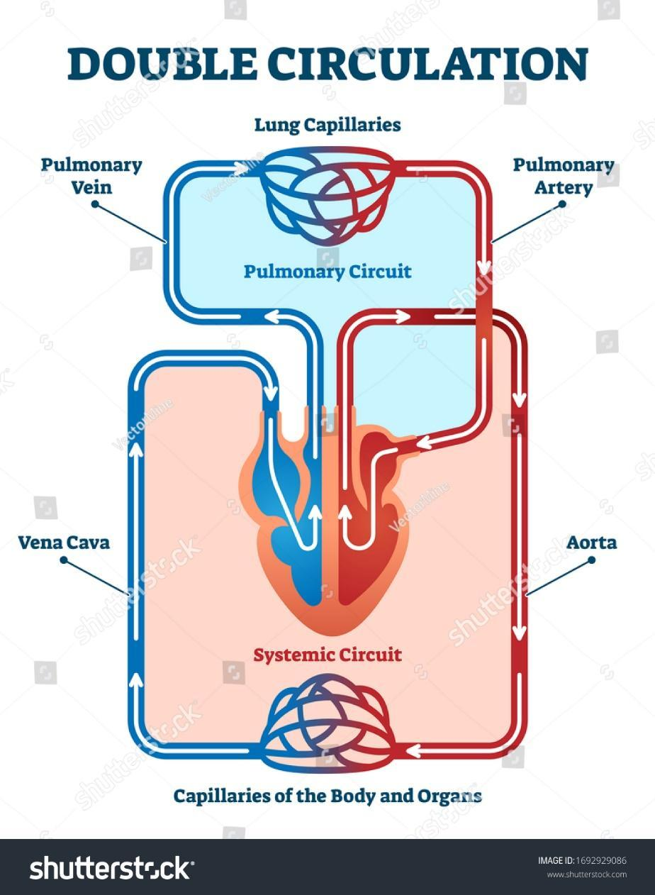

**Blood circulation**